Aquinas College of Higher Studies
Assessment: 1
Qualification:  Course Title: | Bachelors of Education  Soft Skills for Teachers ( BDP 1104.03)
Student Name
Student Registration Number
Assignment Due Date | 30th April 2026
Assignment Submission Date
Word Count

Declaration of authenticity:
- I declare that the attached submission is my own original work. No significant part of it has been submitted for any other assignment and I have acknowledged in my notes and bibliography all written and electronic sources used.
- I acknowledge that my assignment will be subject to electronic scrutiny for academic honesty.
- I understand that failure to meet these guidelines may instigate the centre’s malpractice procedures and risk failure of the unit and / or qualification.

Signature: Date:

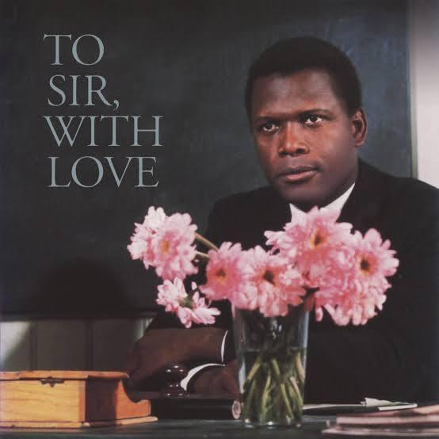
Movie Based Case Study: To Sir, with Love
Movie Link : https://m.ok.ru/video/3656141638355
(Please get in touch if you have trouble viewing the movie)

Instructions

Objective
To analyze the application of soft skills in an educational context using a film-based case study.

Instructions
Watch the movie “To Sir, with Love” attentively. Identify key soft skills demonstrated by the teacher Mr. Mark Thackeray.
Write a case study report addressing the following:
- Brief summary of the movie (no more than one paragraph /100 - 150 words )
- Identification of at least five soft skills shown in the film. Specific scenes or examples that illustrate these soft skills
- Analysis of how these soft skills influence learning, behavior, and relationships
- Personal reflection: What lessons can you apply to your own academic or professional life?

Submission Format
Use clear headings and logical organization.
1,000–1,200 words
Typed Original work; plagiarism will not be accepted
Papers will be checked for AI. Therefore AI contribution should not exceed approximately 15% of the assignment. Papers exceeding 15% will be penalized up to 75% of the allocated marks .

